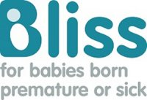
BLISS
Telephone: Dianne Bennett (01428) 642320
Web: www.bliss.org.uk/
e-mail: db.haslemere@btinternet.com
Bliss, the national charity for premature or sick babies, exists to ensure every baby born premature or sick in the UK has the best chance of survival and quality of life. Haslemere branch raises funds and runs a knitting circle to make tiny clothes. If you've had a prem baby please get in touch. You can use the website and helpline for information and support.

