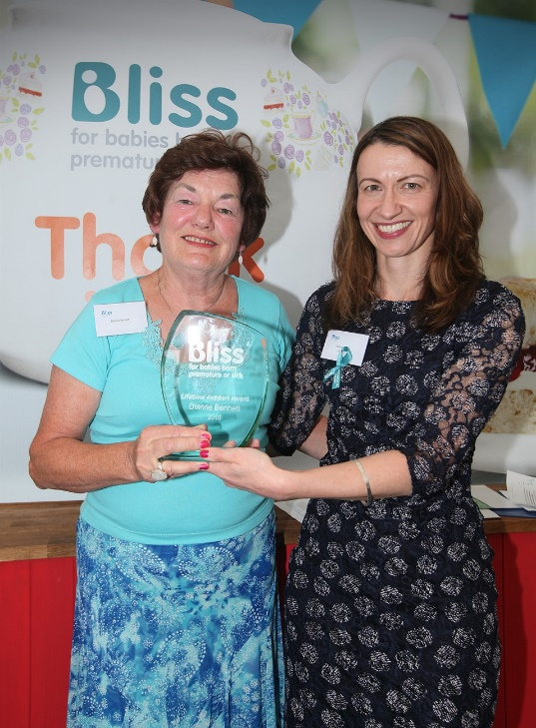
BLISS

Dianne Bennett – Lifetime Achievement Award 2016
(Taken from the Bliss Website)
Dianne became involved with Bliss after becoming mother to three premature babies. Her oldest son Huw was born four weeks early. Her second son, Sam, was born 13 weeks early by emergency caesarean section after Dianne unexpectedly went into labour; sadly Sam died at six hours old. Then her daughter Carys was also born 13 weeks early.
After the devastation of losing Sam and the euphoria of bringing Carys home from hospital, Dianne wanted to do something to pay back the huge debt of gratitude she felt for the excellent neonatal care her daughter had received. She joined Bliss in 1984, quickly becoming a Trustee – a role she faithfully fulfilled until 2006.

Dianne continues to organise an annual Charities Fair and also runs a thriving knitting scheme with 227 members from the Haslemere area. Each year they make hundreds of little cot covers, sets of clothes and Christmas stockings that are donated to hospitals all over the south of England and beyond.

